## Fact sheet A (for the project team from the engineering firm)

Automated robot helpers are being increasingly bought by families to deal with household chores and among the various functions these robots possess, effectiveness in floor cleaning is what many families are concerned about. Different models of floor cleaning robots have been debuted in recent years. While these robots have taken household automation to a new level, the technology itself is not without its problems. Some of the major drawbacks of most current robots include their inaccuracy in mapping the household environmental data (e.g., they are unable to reach specific places) and their high prices. They also require frequent maintenance as they do not have a large enough dirt collection compartment which is so often constrained by their tiny sizes.

You and your team members work for an engineering firm which specializes in robotics. Several representatives from a local household appliances manufacturer have recently attended a seminar in which your team presented the latest robotic technologies. Impressed by your presentation, one of the representatives has contacted you to meet up with your team to discuss the possibility of running a project for their company.

### You will be asked to provide relevant information during the meeting. Now think about how you will introduce yourselves and your firm by filling in the table below, and consider the questions your clients might ask you. You will be asked to provide relevant information during the meeting.

|  |  |
| --- | --- |
| **Name of your firm** |  |
| **Past clients served** |  |
| **Relevant project experiences** |  |
| **Services delivered in past projects** |  |
| **Charges** | HK$1.5 – 3 million, depending on the project scale |
| **Roles of each team member (to be introduced to your clients)** | Project Leader:  Design Engineer:  Technical Engineer:  Sales Engineer: |

### Fact sheet B (for the client representatives from a local household appliances manufacturer)

Recently there has been a growing market for floor cleaning robots. While the existing models have taken household automation to a new level, they suffer from various drawbacks such as (a) inaccurate mappings between the sensor and household environments and thus they sometimes fail to avoid obstacles or reach awkward corners, (b) limited dirt collection capacity so that users have to clean out the dirt bag every so often, (c) sometimes bulkiness in size, and (d) lack of user-friendly remote controls.

You and your team members are representatives from a local household appliances manufacturer. Seeing the potential in the market for such robots, your company has plans to develop and manufacture new models to enlarge your market share. Therefore, your team has been assigned to look for an engineering firm that can develop a prototype of a new model. You have recently attended a seminar in which an engineering firm presented on the latest robotics technologies. Impressed by their ideas, your team intends to hire their professional service for the project at your company.

One of your team members has contacted the presenters and arranged a meeting with them to discuss the related technologies and the possibility of developing the prototype. Now take some time to think about the information from this fact sheet, and be prepared to explain it to the team of engineers during the meeting.

**Parameters / Requirements**

***Technical Specifications / Deliverables***

The engineering firm will need to be able to design and develop a new prototype of the floor cleaning robot with the following specifications / details:

* a new robotic vision system to improve its mapping ability in household environments
* a camera that can be activated online to act also as a surveillance system for the house
* a high-capacity and efficient dirt collection system
* an easy-to-operate system that is safe (e.g. households with pets and fragile items)
* a climbing capacity so the robot can climb stairs
* a high-energy efficient battery that is easy for recharging
* a series of colors for consumers to choose from, and also a Walt Disney limited edition series with the two characters below. Your manufacturer is in the process of seeking a licensing agreement with Disney Enterprises, Inc.

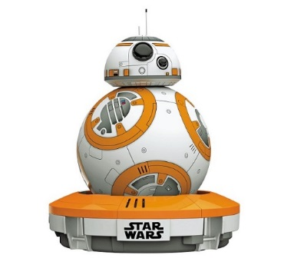 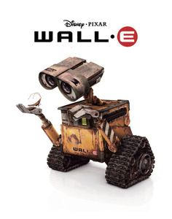

**Wall-E from the animation WALL-E**

**BB-8 droid from the Star Wars movies**

The engineers are to create a design with the above features and present them to you in a blueprint. They will also need to provide user manuals and post-sales technical support and maintenance.

***Project duration:*** 12 months, starting preferably on ________________________ (date)

***Budget:*** HK$1 – 2.5 million

You may think about how you will introduce your company by filling in the table below:

|  |  |
| --- | --- |
| **Name of your company or organization** |  |
| **Role of each team member** |  |
| **Other requirements and needs to be conveyed to the project team** |  |